NAME | Date | Band
Introduction to Optimization (Part II)
Calculus | Packer Collegiate institute

Challenge #1

Label the marked point and then all of the sides of the rectangle. (The equation of the line was $x+5y=10$.)
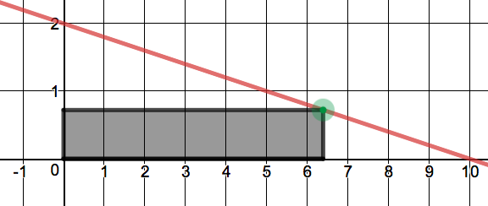

Use calculus to determine the dimensions of the rectangle with the largest area.

Width: Height: Area:
Challenge #3

Label the marked point and the base and height of the triangle. (The equation of the parabola was $y=9-x^{2}$.)
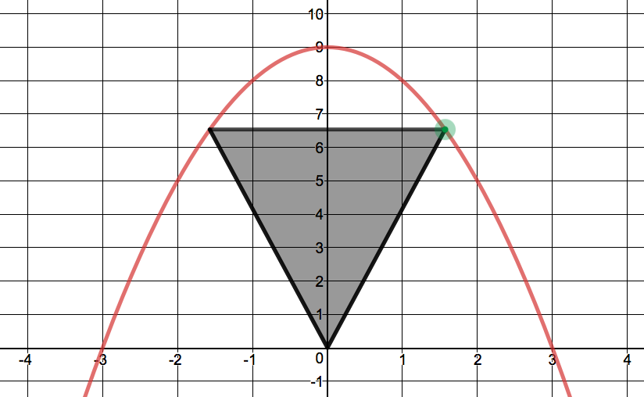

Use calculus to determine the dimensions of the triangle with the largest area.

Base: Height: Area:
Challenge #4

Label the marked point and the trapezoid’s bases and height. (The equation of the parabola was $y=4-x^{2}$.)
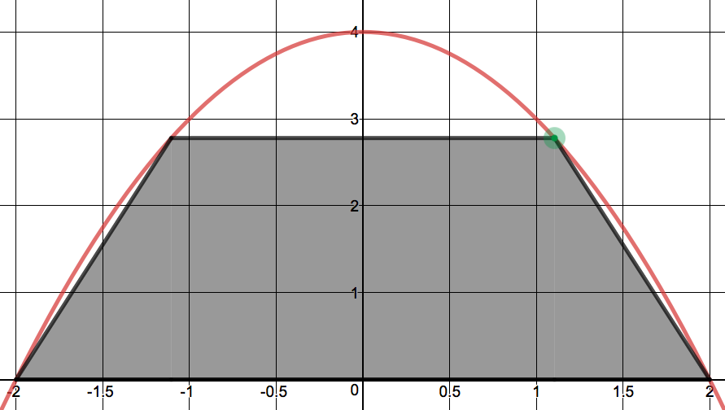

Use calculus to determine the dimensions of the trapezoid with the largest area.

Base₁: Base₂: Height: Area:

