NAME | Date | Band
Introduction to Optimization
Calculus | Packer Collegiate institute

Challenge #1

Draw the rectangle you came up with in Desmos. (The equation of the line was $x+5y=10$.)
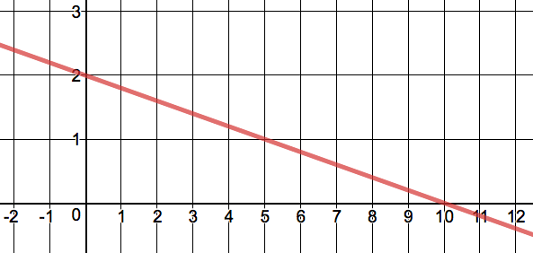

Width: Height: Area:

Challenge #2

Draw the rectangle you came up with in Desmos. (The equation of the parabola was $y=16-x^{2}$.)
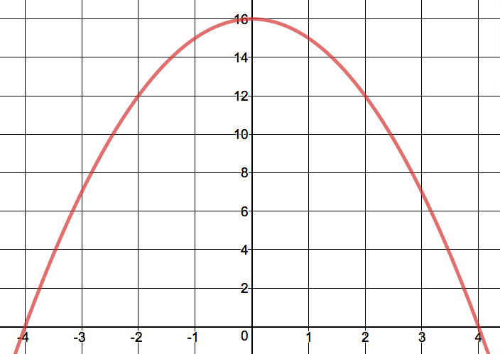

Width: Height: Area:

Challenge #3

Draw the isosceles triangle you came up with in Desmos. (The equation of the parabola was $y=9-x^{2}$.)
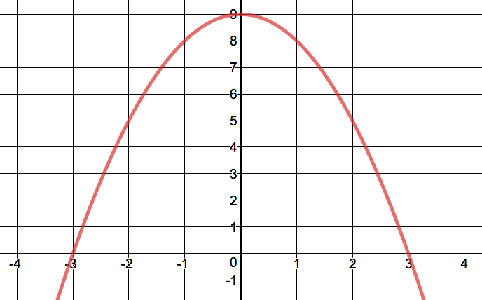

Width: Height: Area:

Challenge #4

Draw the isosceles trapezoid you came up with in Desmos. (The equation of the parabola was $y=4-x^{2}$.)

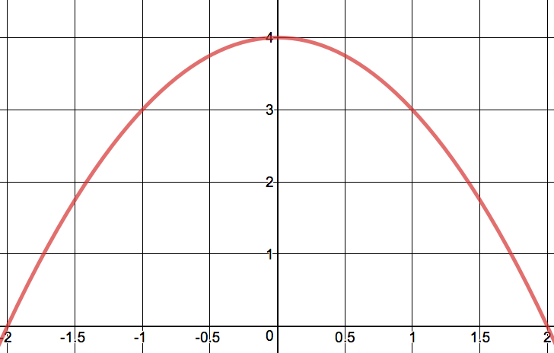

Width: Height: Area:
Challenge #2 (reprise)

Now let’s plot the area of each rectangle as a function of the $x$-coordinate of its corner in Quadrant I.

- To get started, let’s revist the rectangle you drew for Challenge #2 the first time. Record the following:

The $x$-coordinate of the corner in Quadrant I: The area of the rectangle:

- Plot this point below. Then, use Desmos to help you plot any eight additional points.

- These points seem to outline a curve. Gosh, wouldn’t it be great if we could figure out an equation for this curve? (Yes / No / Maybe So )

- Fill in the blank below. Then, label all of the sides of the rectangle in terms of $a$.

- Write down a function for the area of the rectangle as a function of $a$:

RectArea$\left(a\right)=$

- Plot your function in Desmos! Then, fill in the blank:

The maximum possible area was approximately , and this occurred when $a$ was approximately .

- Sketch the best rectangle below, labeling its width, height, and area:
Calculus to the rescue!

Our next question is this—how could we have determined the dimensions of this rectangle without Desmos?

- Remind me—if $f(x)$ has a maximum (a peak) at a certain $x$-value—like $x=a$, for example—what must be the value of $f'(a)$?

- Determine RectArea’$(x)$.

- Let’s figure out what our candidate points are by setting RectArea’$\left(x\right)=0$ and solving for $x$.

- Finally, determine the best rectangle’s exact dimensions and area.

